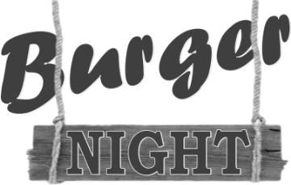

Pint for a Pound…
With any Burger on Burger night
(Includes All Lancaster Ales & Kaltenberg Lager Only)
Offer not In conjunction with any other offers

All served on a Brioche Bun; Crisp Salad, Chips
Dukes Steak Burger - £13
Chargrilled Local Steak Burger, Bacon, Cheese, Burger Sauce
Piri-Piri Chicken Burger - £12
Chargrilled Chicken Coated in Piri-Piri, Sweet Chilli Mayo
Hunters Chicken Burger- £12
Charred Chicken, Bacon, Cheese, BBQ Sauce
Southern Fried Chicken Burger- £12
Fried Breaded Chicken Breast, Cheese, BBQ Sauce
Falafel, Spinach & Chickpea Burger - £11
Toasted Brioche Bun, Cheese, Salad, Coleslaw, Chips, Sweet Chilli Mayo

Add Steak Pattie Burger - £4 Add Southern Fried Chicken Fillet - £4
Upgrade to Salt ‘n’ Pepper Chips or Sweet Potato Fries - £1

